**Senior Analyst – Workflow Optimization & Analytics (Pharmacy)**

R20001999986

|  |  |
| --- | --- |
| **Candidate Name:** | Edima Udo |
| **Date:** |  |
| * There are 3 sections to this document. Please read through carefully. * Please keep your answers brief and specific to the question * Please have your response as point form only. * Save the document in the format: **First Name, Last Name - Role** * Attach your responses back to this e-mail * Please mark your answers in blue after each question. * Please save in a word format and return a copy within 48 hours. | |

**SECTION A – Prescreen**

1. **Are you legally eligible to work in Canada** (highlight one)**? Yes**/ No
2. **A criminal history check is a component of our recruitment process. In the event of an offer are you willing to complete this step** (highlight one)**? Yes**/ No

1. **Have you previously worked with Loblaw (any banners) or Shoppers Drug Mart in the past** (highlight one)**?** Yes/ **No**
2. **This job is based out of North York (Head office), does that work for you? Yes** / No

*\*please note that due to Covid-19, this position based out of working from home with the exception of coming to the office for training purposes or to pick up your assets\**

1. **What is your reason for seeking employment?**

**Looking for work that is fulfilling, pushes me to think differently, solve challenging problems and help stakeholders (external and internal) achieve their goals**

1. **Summarize your experience as it pertains to this role.** *(3 points)*

**I have extensive experience in retail operations (supply chain, merchandising operations, workforce operations). In these roles I worked collaboratively with different users, built business tools, led projects that generated savings and efficiencies for the business. This coupled with my background in industrial/management engineering helps me bring strong technical and business acumen to the role. I can come up with better insights based on my ability to see problems from different retail perspectives.**

1. **What is your total compensation expectation for this role?** *(please provide a range, even if it is negotiable)* **76000 – 85000 CAD**
2. **In an event of an offer, how much notice do you require to start with us?** *(highlight one)*

**2 weeks** | 3 weeks | or more | ASAP

**FOR INTERNAL APPLICANTS ONLY –**

**Have you made your current manager aware of your candidacy for this role?** Yes/ No ***If not, please make them aware before moving forward in the process.***

**SECTION B – Experiential Evaluation**

**Please describe a project where you applied your combination of analytical and business skills to discover a *business insight*, which lead to a positive and tangible impact. Your response should address the following questions:**

1. **What was the problem and how did you identify it?**
2. **How did you acquire the data, and what uniqueness or complexity made it challenging?**
3. **What analytical or modeling steps did you subsequently take and why did you choose them?**
4. **Describe the insight/conclusion and business benefit attained from your work.**
5. **What risks or caveats would you describe about your conclusion?**
6. **Reflecting on your project, what could you have done better?**

**One of the analytical projects that involved applying my analytical and business skill was when I worked at Canadian Tire.  The project involved analyzing our regular pricing process and find areas for improvement.  The main customer was store managers. The project was identified during a senior leadership meeting.  Store managers raised issues during the meeting about the inconsistent pricing.**

**The data was obtained from the Enterprise Data Warehouse (EDW) of the company.  The team in charge of the current pricing process was the pricing team.  The complexity came from the fact that the pricing team did not have a consistent pricing process.  So even if they used the same data, they would get different prices at the end of the pricing process.**

**My approach was to apply descriptive analytics to find out which business categories had the most inconsistent pricing based on the pricing rules.  I chose this method as it would help me find out where the core issues were quickly.  Based on this process I noticed the inconsistent pricing was across all business categories.  A project was undertaken to centralize the pricing process using a database application which would take all the pricing from the pricing analyst and then apply the proper pricing rules by business categories.**

**The benefit attained was that it reduced inconsistent pricing by close to 90% which saved store managers about 80% rework time when changing prices.  An unforeseen risk was the pricing team downsizing by two members due to the improved accuracy of the system. From a system perspective since it used Access and Excel I made sure to add VBA to handle unforeseen errors that could be generated by Access or excel.**

**Reflecting on the project, one thing I could have done better is created better documentation on pricing rules so that it would be easy to track changes and new pricing rules additions.**

**SECTION C – Technical Skills Evaluation**

1. **If we observe the timing of a stochastic process to be between 30 and 36 seconds with a confidence of 90%, what is the most likely new confidence interval if you are asked for 95% confidence? *(Highlight one)***
2. **Between 26 and 40 seconds**
3. Between 32 and 42 seconds
4. Between 30 and 36 seconds
5. **Suppose there are two fast-food coffee chains. The average end-to-end coffee preparation time at Java James is 4 minutes and 52 seconds. Koehler's Kafe, on the other hand, averages 5 minutes and 5 seconds. Customers expect to wait no more than 5 minutes for coffee. Which statement can we *conclusively* make? *(Select all that apply)***
6. **James has more customers served within 5 minutes**
7. James has less variability in his coffee-making process
8. There is more value-added time in Koehler's process
9. None of the above
10. **What advantages does single-variate linear regression have when *compared against* correlation? (Select all that apply)**
11. Predicts the direction change in Y, given a directional change in X
12. Predicts the magnitude change in Y, given a magnitude change in X
13. **Predicts Y, given a value of zero for X (the intercept)**
14. Implies that the change in Y was caused by the change in X
15. **You are assessing the business case for a 3-year pharmacy initiative, which will cost $280,000 initially (year 0) and is expected to generate additional revenue of $80,000 by the end of the first year in operation, $130,000 for year 2, and $190,000 for year 3. Assume a discount rate of 3.5%. What is the approximate value in today's dollars of the entire initiative? \***
16. $120,000
17. $100,000
18. **$90,000**
19. **You are asked to lead an analysis to forecast the busiest hours (e.g. 6pm) in pharmacy, first by generating the expected hourly “demand curve” for each of our stores in 2019. A snippet of the available data is below.**

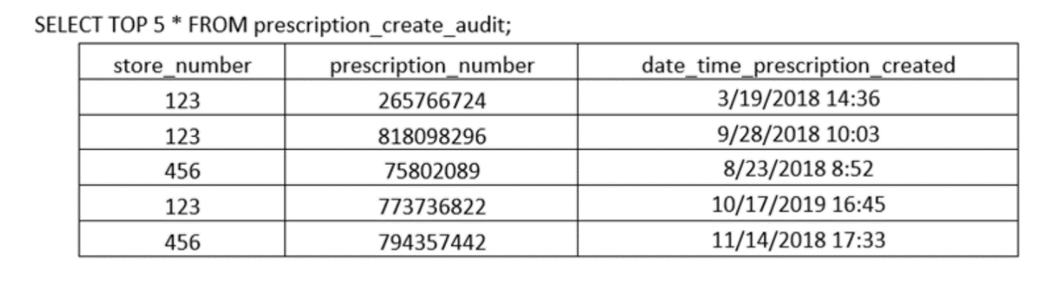**Submit a query to generate this desired output, feel free to use any SQL syntax/implementation (e.g. SQL Server, DB2) you are most comfortable with.**

**For the above SQL exercise, what assumptions did you make, and what clarifications might you ask for?**

Select p.STORE_NUMBER,

COUNT(p.PRESCRIPTION_NUMBER) AS DEMAND,

LEFT(CAST(cast(p.`date_time_prescription_created` as TIME) AS CHAR),2) AS HOUR_INFO

FROM `prescription_create_audit` as p

where year(cast(p.`date_time_prescription_created` as date)) = '2019'

GROUP BY p.STORE_NUMBER, LEFT(CAST(cast(p.`date_time_prescription_created` as TIME) AS CHAR),2)

ORDER BY 1,2,3 ASC

**Assumptions**

* All the data needed is available
* The timeframe needed is all of 2019

**Clarifications**

* Are there any edge cases for the time period given?
* What other data points are available and how large is the data?
* Is this the correct data table being used?
* What other metrics would be needed?
* Who are the stakeholders involved?